Ex. No. : 08 - B Date :
Register No. : 221701037 Name : MOHAN VAITHYA

Send EMAIL
Aim
Develop an application to send Email.

Procedure:

Step 1 : File → New Project
Provide the application name (e.g.,"Email") and click “Next”.
Step 2 : Select the target Android devices
Select the minimum SDK to run the application. Click “Next”.
Step 3 : Choose the activity for the application
By default, choose “Blank Activity”. Click “Next”.
Step 4 : Enter activity name and click “Finish”.
Step 5 : Edit the program
Design the UI for entering recipient email, subject, and message.
Use an implicit intent (Intent.ACTION_SEND) in MainActivity.kt to
trigger the email client with pre-filled details.
Step 6 : Run the application
Two ways to run the application:
1. Running through emulator
2. Running through mobile device
AndroidManifest.xml

<?xml version="1.0" encoding="utf-8"?>
<manifest xmlns:android="http://schemas.android.com/apk/res/android"
package="com.example.email">

<!-- Add internet permission -->
<uses-permission android:name="android.permission.INTERNET" />

<application
android:allowBackup="true"
android:icon="@mipmap/ic_launcher"
android:label="@string/app_name"
android:roundIcon="@mipmap/ic_launcher_round"
android:supportsRtl="true"
android:theme="@style/Theme.SendEmail">
<activity
android:name=".MainActivity"
android:exported="true">
<intent-filter>
<action android:name="android.intent.action.MAIN" />
<category android:name="android.intent.category.LAUNCHER" />
</intent-filter>
</activity>
</application>

</manifest>

Activity_main.xml

<?xml version="1.0" encoding="utf-8"?>
<LinearLayout xmlns:android="http://schemas.android.com/apk/res/android"
xmlns:tools="http://schemas.android.com/tools"
android:layout_width="match_parent"
android:layout_height="match_parent"
android:orientation="vertical"
tools:context=".MainActivity">
<!-- Header -->
<TextView
android:layout_width="match_parent"
android:layout_height="wrap_content"
android:background="@color/purple_primary"
android:padding="16dp"
android:text="Send Email"
android:textColor="@android:color/white"
android:textSize="20sp"
android:textStyle="bold"
android:contentDescription="Send Email screen" />
<!-- Email To Field -->
<TextView
android:layout_width="wrap_content"
android:layout_height="wrap_content"
android:layout_marginStart="16dp"
android:layout_marginTop="16dp"
android:text="To"
android:textColor="@android:color/black"
android:labelFor="@+id/to_edit_text" />
<EditText
android:id="@+id/to_edit_text"
android:layout_width="match_parent"
android:layout_height="wrap_content"
android:layout_marginStart="16dp"
android:layout_marginEnd="16dp"
android:background="@drawable/edit_text_bottom_line"
android:hint="Email address"
android:importantForAutofill="yes"
android:autofillHints="emailAddress"
android:inputType="textEmailAddress"
android:padding="16dp"
android:minHeight="48dp"
android:textSize="16sp" />
<!-- Subject Field -->
<TextView
android:layout_width="wrap_content"
android:layout_height="wrap_content"
android:layout_marginStart="16dp"
android:layout_marginTop="16dp"
android:text="Subject"
android:textColor="@android:color/black"
android:labelFor="@+id/subject_edit_text" />
<EditText
android:id="@+id/subject_edit_text"
android:layout_width="match_parent"
android:layout_height="wrap_content"
android:layout_marginStart="16dp"
android:layout_marginEnd="16dp"
android:background="@drawable/edit_text_bottom_line"
android:hint="Subject"
android:importantForAutofill="yes"
android:autofillHints="subject"
android:inputType="textCapSentences"
android:padding="16dp"
android:minHeight="48dp"
android:textSize="16sp" />
<!-- Message Field -->
<TextView
android:layout_width="wrap_content"
android:layout_height="wrap_content"
android:layout_marginStart="16dp"
android:layout_marginTop="16dp"
android:text="Message"
android:textColor="@android:color/black"
android:labelFor="@+id/message_edit_text" />
<EditText
android:id="@+id/message_edit_text"
android:layout_width="match_parent"
android:layout_height="wrap_content"
android:layout_marginStart="16dp"
android:layout_marginEnd="16dp"
android:background="@drawable/edit_text_bottom_line"
android:gravity="top"
android:hint="Type your message"
android:importantForAutofill="yes"
android:autofillHints="emailBody"
android:inputType="textMultiLine"
android:minLines="3"
android:minHeight="96dp"
android:padding="16dp"
android:textSize="16sp" />
<!-- Send Button -->
<Button
android:id="@+id/send_button"
android:layout_width="match_parent"
android:layout_height="wrap_content"
android:layout_marginStart="16dp"
android:layout_marginTop="24dp"
android:layout_marginEnd="16dp"
android:background="@drawable/purple_button_background"
android:text="Send"
android:textAllCaps="false"
android:textColor="@android:color/white"
android:minHeight="48dp"
android:textSize="16sp" />
</LinearLayout>

MainActivity.kt

package com.example.email
import android.content.Intent
import android.net.Uri
import android.os.Bundle
import android.widget.Button
import android.widget.EditText
import android.widget.Toast
import android.appcompat.app.AppCompatActivity

class MainActivity : AppCompatActivity() {

private lateinit var toEditText: EditText
private lateinit var subjectEditText: EditText
private lateinit var messageEditText: EditText
private lateinit var sendButton: Button

override fun onCreate(savedInstanceState: Bundle?) {
super.onCreate(savedInstanceState)
setContentView(R.layout.activity_main)

// Initialize UI components
toEditText = findViewById(R.id.to_edit_text)
subjectEditText = findViewById(R.id.subject_edit_text)
messageEditText = findViewById(R.id.message_edit_text)
sendButton = findViewById(R.id.send_button)

// Set up send button click listener
sendButton.setOnClickListener {
sendEmail()
}
}

private fun sendEmail() {
val recipient = toEditText.text.toString().trim()
val subject = subjectEditText.text.toString().trim()
val message = messageEditText.text.toString().trim()

// Basic validation
if (recipient.isEmpty()) {
Toast.makeText(this, "Please enter recipient email", Toast.LENGTH_SHORT).show()
return
}

try {
// Try first with ACTION_SENDTO (preferred way for email)
val emailIntent = Intent(Intent.ACTION_SENDTO).apply {
data = Uri.parse("mailto:") // only email apps should handle this
putExtra(Intent.EXTRA_EMAIL, arrayOf(recipient))
putExtra(Intent.EXTRA_SUBJECT, subject)
putExtra(Intent.EXTRA_TEXT, message)
}

// Check if there's a matching activity
if (emailIntent.resolveActivity(packageManager) != null) {
startActivity(emailIntent)
return
}

// Fallback to ACTION_SEND (more general, will show more apps)
val sendIntent = Intent(Intent.ACTION_SEND).apply {
type = "message/rfc822" // email mime type
putExtra(Intent.EXTRA_EMAIL, arrayOf(recipient))
putExtra(Intent.EXTRA_SUBJECT, subject)
putExtra(Intent.EXTRA_TEXT, message)
}

// Use createChooser to always show options even if default is set
startActivity(Intent.createChooser(sendIntent, "Send email using..."))

} catch (e: Exception) {
// Show more detailed error message
Toast.makeText(
this,
"No email app available. Error: ${e.message}",
Toast.LENGTH_LONG
).show()
e.printStackTrace()
}
}
}

Output

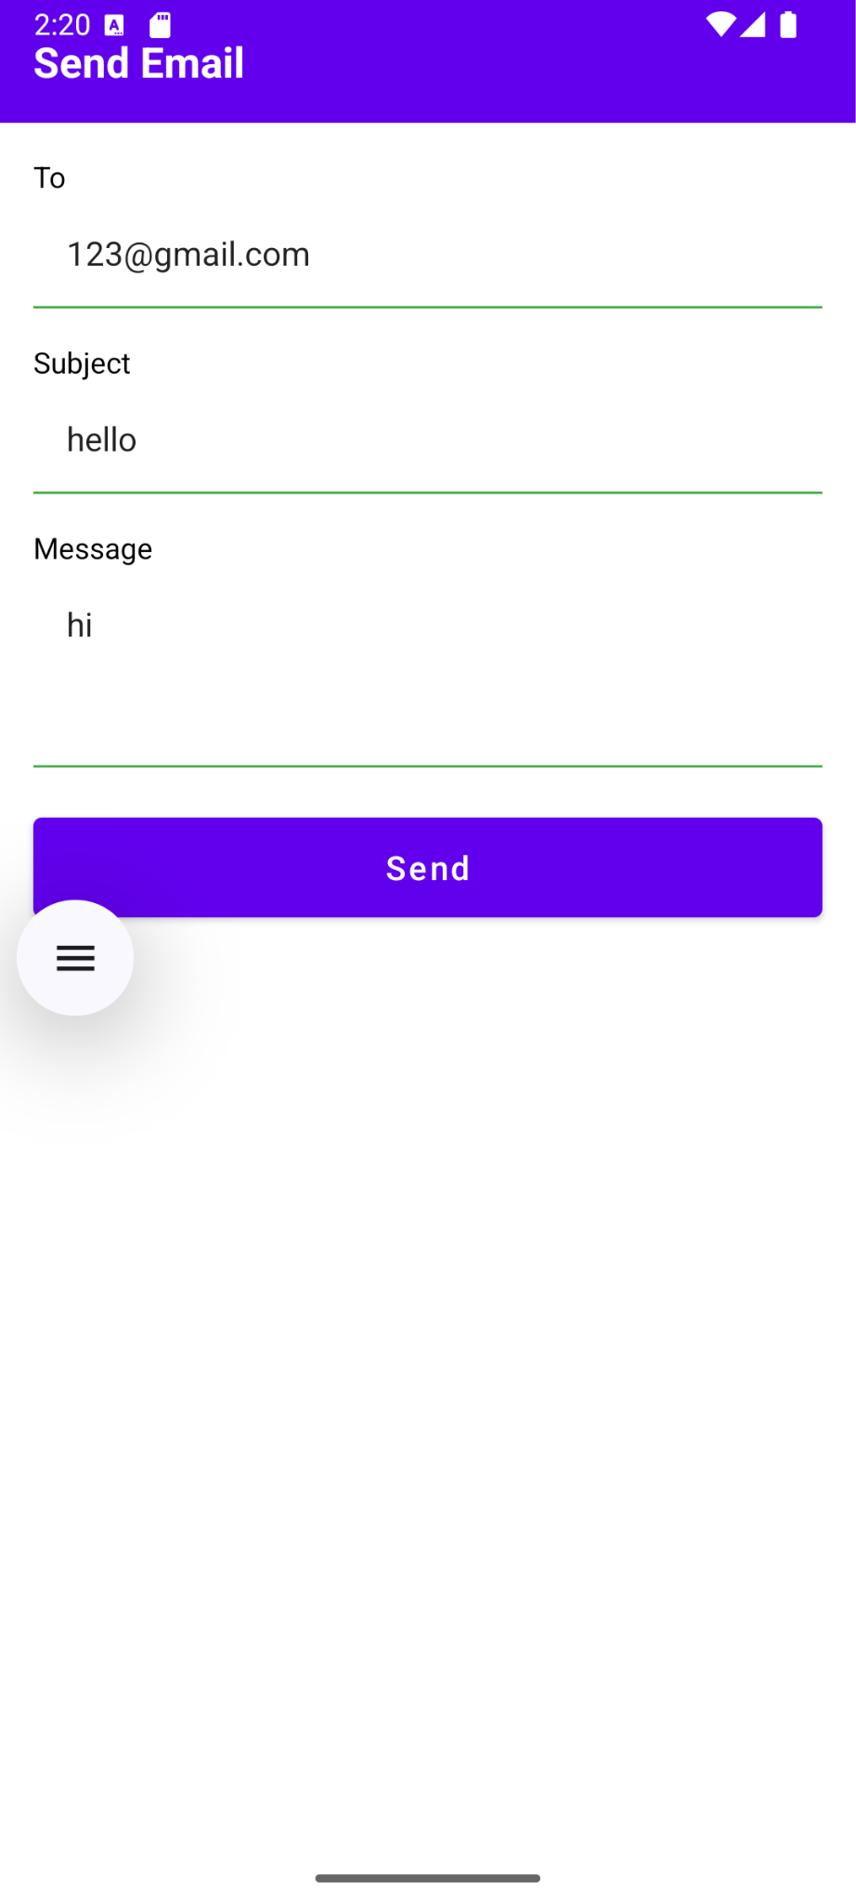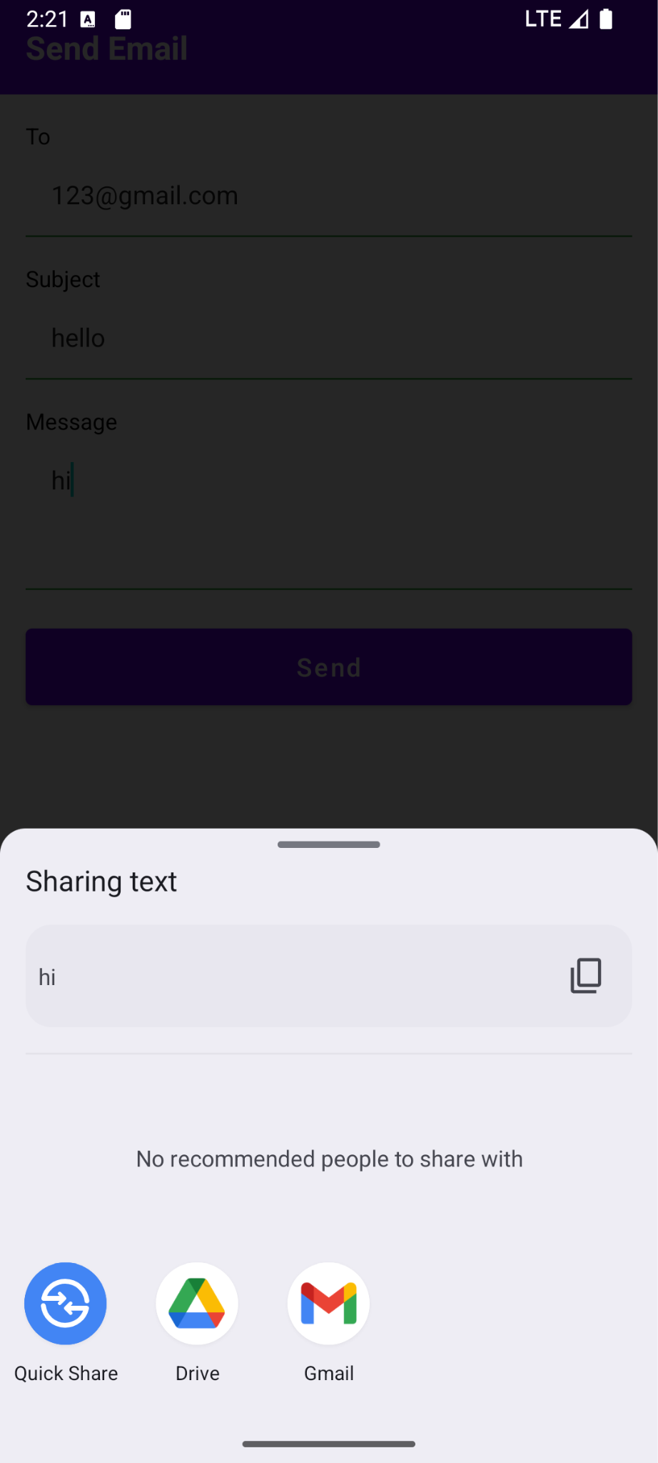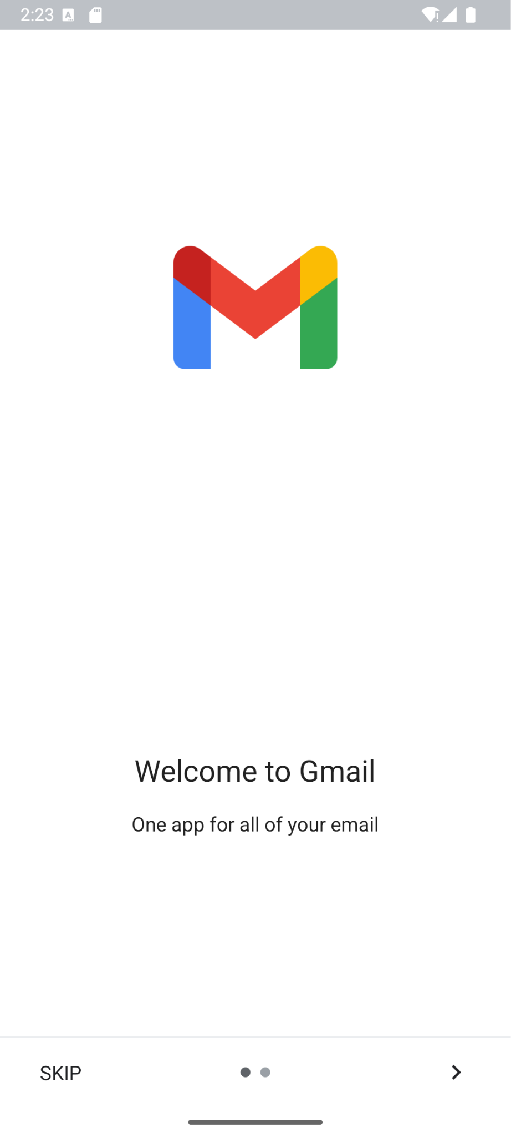

Result:
The Email application successfully opens the email client with pre-filled recipient, subject, and message, allowing the user to send an email via their preferred email app.

